Memorandum
Harris CountyJuvenile probation department
1200 Congress Avenue Houston, TX 77002

Student(s) name: Douglas | Report title/topic: Monitors
Criteria | Comments |  | Points
Writing: Does the writer persuade the reader to fund or implement his/her idea? Is the report well written on the sentence level in terms of grammar, style, and expression? See Track Changes.  (10 points)  Look carefully at my comments and your own writing. There are places that almost appear to be random words. Some sentences are repeated and there are many words or sentences to do not make sense. I do not know if this was because of careless copying and pasting or just inattentive editing, but the report was very hard to understand. |  | 4
Genre conventions: Front matter: Does the paper meet the conventions of the genre?
- Front matter/first page/format  (2 points)  - Letter format if external  - Memo format if internal  - Conventions followed |  |  | 1
Research: Is the research thorough and compelling?
- Body (10 points)  - Introduction  - Research  - Discussion  - Conclusion | You do have some research here but overall you did not make your research process evident to the reader. |  | 4
Genre conventions: Back matter: Does the paper meet the conventions of the genre?
- Back matter (1 point)  - Works cited  - Appendices |  |  | 1
Visual conventions: Are the visual elements purposeful, truthful, clear, and interesting?
- Visuals: (2 points)  - Are the visuals purposeful, truthful, clear, and interesting  - Are the visuals labeled and placed in appropriate locations? |  |  | 2
Total: 12/25 points
Grade Range
A = 25-22.5 points B = 22.49-20 points C = 19.99-17.5 points D = 17.49-15 points F = below 14.99 points

Date: November 29, 2018
To: Finance Committee/Public
From: LaQuana Douglas, Juvenile Supervision Officer
Subject: The use of Electronic Monitoring devices to monitor juvenile convicts
The purpose of this proposal is divulge information on the need of Harris County Juvenile Probation Department to introduce EM devices to juvenile offenders

INTRODUCTION
Throughout my duration with the Harris County Juvenile Probation Department, I realized several issues related to the juveniles. Among them is that many youths get admitted to the probation department in a day which sometimes causes congestion in the facilities. Secondly, most of the juveniles do not return to the court after their home visit duration is over. On this, it becomes a hectic thing for the responsible staffs to trace the whereabouts of the convicts when they do not return. With these two issues at the Harris County Juvenile Department, it would be a good idea to introduce an electronic monitoring device that comprises the Geographical Positioning System (GPS). The devices can be such that it be quickly put on the ankle and can only be removed by the staff from sheriff office. In this way, it will be easy to trace the exact location of the convict when they temporally leave for a home visit.
The electronic monitoring device maintains the records on the movement of juvenile defendants wherever they go. Although, the device does not prevent the convicts from committing a crime while outside the court, they are useful in determining if the juvenile defendants were anywhere near the crime scene. As such, the use of device acts as an alternative way of securing detention for the juvenile. This idea would help in reducing congestion in the facilities. I am therefore, proposing for the introduction of ankle electronic monitoring device in the department due to its critical benefits to the probationers in locating the juvenile convicts. 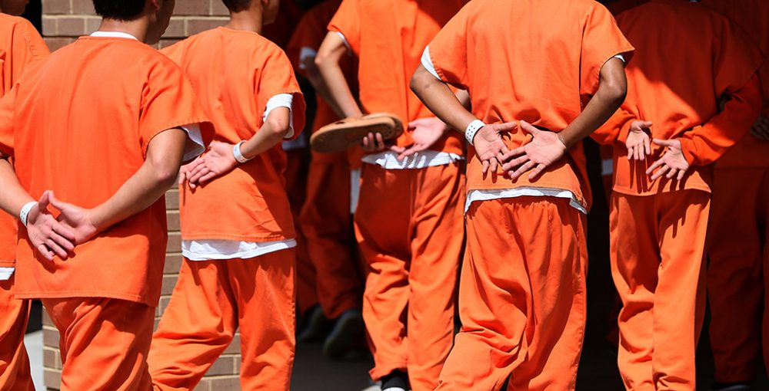
Source: Texas Juvenile Justice Department and local juvenile Justice (2017)
Research
The number of adolescents who are and have been in the court continues to increase each day. According to the report from the Harris County Juvenile Probation Department, youths aged between 10 to 17 years are frequently charged with a misdemeanor, felony the same way adults are treated. A juvenile offender can still be charged for illegal activities like abuse of drugs and possession, truancy, rape, robbery, violation of traffic rules, arson, possession of weapons and murder (Budd, Kristen and Mancini 1). According to the Juvenile Probation Department monthly report of 2017, all these crimes from different youths in different locations contribute to an average of 921 convicts every month.
The use of Electronic Monitoring devices is a useful tool for home confinement programs, home detention and house arrest. In most cases, the offenders are at risk of committing another offence when they are at temporally home visit making them become absconders. If in any case, the juvenile offender had an ankle EM or a wrist EM it would be easier for the officers to verify that the convict was not involved in such crimes. Also, EM can be used in communicating with offenders like asking them to return to jail upon parole hearing or after an investigation.
DISCUSSION
The electronic monitoring device incorporates the supervision of guilty parties through any electronic gadget that tracks the whereabouts of wrongdoers either irregularly or persistently. After being imposed on an electronic checking program, wrongdoers must consent to pay the required expense set by the courts. Probation officers regularly manage guilty parties who are put on an electronic monitor. These officers oversee the offenders to guarantee them a consistency with the court orders and exploring infringement. In contrast to EM, different options were intended to be utilized such as those related to other network-based projects. For instance, house capture, curfews, network benefit, and so forth were some of the alternatives used.
However, guilty juvenile offenders might be put in electronic monitoring either pretrial or as an immediate sentence for probation through a network or redresses based program. Electronic checking has been utilized with an assortment of guilty parties including sex wrongdoers, rough guilty parties, aggressive behavior at home wrongdoers, and pack individuals (HCJPD 2017). While every one of these projects contrasts by the motivation behind their organization, the supervision obligation continues as before. The guilty parties get arbitrary phone calls for the day when they should be home. 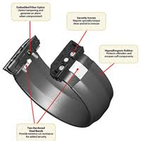
Source: Texas Juvenile Justice Department and local juvenile Justice (2017)
Conclusion
Two main issues that affect the Harris County Juvenile Probation Department facility include Congestion and a failure of juvenile offenders to report back after temporally home visit duration is over. The officers in the departments finds it hard to physically trace the offenders when they are away from the court. The use of Wrist or ankle Electronic Monitoring device would be a solution to these issues. The device is composed of GPS which allows to monitor the movement and trace the location of the juvenile offender at a specific time. With this device, the department can determine whether the juvenile convict was involved in crime while in temporally home visit by examining if the devices was near the crime scene during the time when criminal offence occurred.
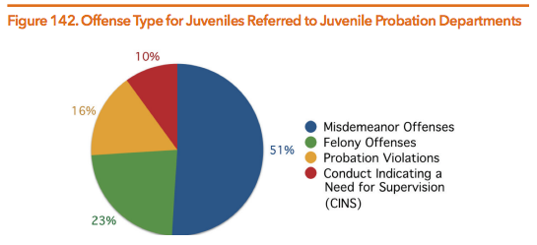
Source: Harris County juvenile probation department report (2017)

I look forward to working more with Harris County Juvenile Probation Department to make sure we are providing safety for our juveniles as well as our community.
If you have questions on this proposal, feel free to contact me at your convenience by email at laquaana.douglas@hcpjpd.com. We will be in touch with you next week to arrange a follow-up conversation on the proposal.
Thank you for your consideration,

Works cited
Budd, Kristen M., and Christina Mancini. "Public perceptions of GPS monitoring for convicted sex offenders: opinions on effectiveness of electronic monitoring to reduce sexual recidivism." International journal of offender therapy and comparative criminology 61.12 (2017): 1335-1353.
HCJPD. "Harris County Juvenile Justice Data Sheet." Juvenile Justice, 2017,

Student(s) name: | Report title/topic:
Criteria | Comments |  | Points
Writing: Does the writer persuade the reader to fund or implement his/her idea? Is the report well written on the sentence level in terms of grammar, style, and expression? See Track Changes.
(10 points)

Does the writer persuade the reader to fund or implement his/her idea?
A below average report contains an idea only. For example, a below average report will proposal to an apartment manager or group that playground equipment be replaced. A below average report may also present the results of an online search of prices of playground equipment.

An average report will propose to a named apartment manager or group that the playground equipment be replaced. An average report will present results of an online search of prices of playground equipment. An average report will include images of the current equipment and make explicit why new equipment is needed. An average report will include a discussion of installation options as well as a timeline. An average report may bring in outside research on apartment amenities and renter satisfaction.

An above average report will propose to a named apartment manager or group that the playground equipment be replaced. An above average report anticipate and answers all of the questions the manager or management group has and makes a compelling case that the reader will see a benefit from the proposed changes. An above average report may include an interview with an apartment manager as well as survey to determine resident interest in or support of new playground equipment. An above average report avoids unsubstantiated leaps in logic. That is, the report does not claim without evidence that better playground will result in higher occupancy rates. A reader can take an above average report to his/her manager who can then confirm the claims in the report and – at least theoretically – proceed with the proposed changes.

Is the report well written on the sentence level in terms of grammar, style, and expression?
Each student has been given feedback throughout the semester on his or her writing on the sentence level. Does the report reflect an understanding of the feedback? Are the 10 suggestions followed or is the report filled with contractions and random capital letters and long paragraphs and meaningless adverbs? Do incomplete sentences or poor word choice diminish the credibility of the writer?

Genre Conventions: Does the paper meet the conventions of the genre?
- Front matter/first page/format  (2 points)  - Letter format if external  - Memo format if internal  - Conventions followed | If the audience for your report is internal (i.e., written to your supervisor), the report will be in memo format.  If the audience for your report is external (i.e., written to members of your HOA), the report will be in letter format.  If your report exceeds five pages in length (not including appendices), then you may want to write a formal report as seen on pages 490-511 of your book. A formal report has a title page, an abstract or executive summary (the example in the book has both), and a table of contents as the “front matter.” The five page designation is somewhat arbitrary. The example on pages 436-442 is seven pages but does not contain the traditional front matter one would find in a formal report.  Your report should follow conventions of technical/professional communication. It should be single spaced throughout and reflect preferred conventions of format and style in terms of font and paragraph length and clarity of expression.

Research: Is the research thorough and compelling?
- Body (10 points)  - Introduction  - Research  - Discussion  - Conclusion/Recommendation | Each report will develop differently, but all reports should have some combination of these or similar elements. Obviously, different topics may require different sections.  The report will have some kind of summary/introduction written after research is concluded and decisions reached. Too many students start with an introduction/summary before they have content to introduce or conclusions to summarize.  There also needs to be evidence of research. The report should not just contain the stated opinion of the writer over and over again. A strong report references relevant outside research from credible sources.  The discussion section reveals whether the writer understands the complexity of the situation by anticipating and answering questions that readers are likely to have. Surveys are explained, not just dropped into the report as though they speak for themselves.  The conclusions/recommendations make sense given the content of the rest of the report.

Genre conventions: Back matter: Does the paper meet the conventions of the genre?
- Back matter (1 point)  - Works cited  - Appendices | Your research will likely include outside sources. These sources need to be cited correctly using an identifiable citation method.  Your report should also have something in an appendix. An appendix appears at the end of the report and contains information that has been appended to (attached or added into) the report itself. The appended information is usually either too detailed to appear in the body of the report or is in some way additional to the report.  So, for example, if you have a long list of “Needed Materials” it may be easier for the reader if you state in the report “Please see Appendix A for a list of needed materials.” The reader can then flip to Appendix A to see a chart with all of the needed materials. Surveys should be discussed and analyzed in the report itself but the survey instrument is often moved out to an appendices, especially if it is long. You, as the writer, must decide if the chart or the survey instrument works better in the report or in the back of the report in the appendix. As always, think in terms of what strategy is easiest for the reader to process the information.  If you do not have something that needs to be moved into an appendix you can always include your resume at the end as evidence of your ability to take on the proposed task or a progress log showing the work you completed on the report. (An example progress log is below.)  A report can have many items in the appendices. Each item is listed separately (Appendix A, Appendix B, etc.) and should be referred to in the report itself.

Visual conventions: Are the visual elements purposeful, truthful, clear, and interesting?
- Visuals (2 points)  - Purposeful, truthful, clear, and interesting  - Labeled and placed in appropriate locations | Your report should contain a visual element. Visuals in technical communication are meaningful. They are not ornamental. They are easy to see and/or read and their content is relevant. Visuals do not mislead a reader. Visuals are labeled and place in close proximity to relevant written content.

